**SRI A.S.N.M GOVERNMENT COLLEGE (A), PALAKOLDEPARTMENTOFCOMMERCE**

**2022-23**

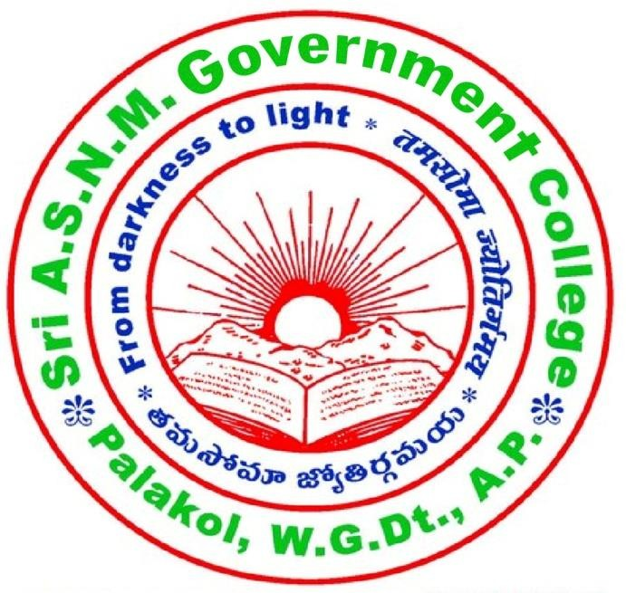

**“WORLD CONSUMER RIGHTS DAY”ON**

**15thMarch2023**

**SRIAS NMGOVERNMENTCOLLEGE(A)**

**Palakol,WestGodavariDistrict, AndhraPradesh- 534260**

**Affiliatedto AdikaviNannayaUniversity,Rajamahendravaram**

**(NAAC Re-accreditedby‘B’Gradewith 2.61CGPA)**

Collegee-mail:sriasnmgdc@gmail.comWebsite:https://sriasnmgdcpalakol.ac.inPhone:08814229069

**DEPARTMENTOFCOMMERCE**

**WorldConsumerRightsDay 15-03-2023**

**Theme:- EmpoweringConsumersthroughCleanEnergyTransitions.**

The department of Commerce and Economics jointly organized WorldConsumer Rights Day on 15th March 2023. Dr.T Raja Rajeswari Principal,SriA.S.N.M.Govt.College (A),PALAKOL, Chaired the Session. Dr S.V. Ranga Rao.,Retd.Principalwasinvitedasachief guest.

World Consumer Rights Days is celebrated on the 15th of March every yeartoraiseglobalawarenessaboutconsumerrightsandneeds.Thedayisanopportunity to promote basic rights of all consumers, demanding that those rightsare respected and protected. It also gives people a chance to protest against themarket abusesandsocial injustices.

Inheropeningremarkschairpersonsightingherreallifeexperiencehas a consumer. She stressed on the importance of knowing the consumer rightsandutilisethemintheirreal lifebusinessencounters.

Speaking on this occasion a chief guest side that we should always everyconsumer why buying any product should take bill from the seller and buyers mustthoroughlycheckthemanufacturingandexpirydatebeforepurchasingtheproducts. He inspired andmotivates the students to speak and respond to thisspeechhegave a cashprizeone studentwhorespondedtohisspeech.

Postar presentation competition was conducted for students around 15students have participated in this event certificates were distributed to students whoparticipatedinpostarpresentation.Inthisprogramstakeholderslikeparents,

alumni,DepartmentIncharges,facultyofcommerceandEconomicsandstudentshaveparticipated.

# Objectives:

1. TopromoteanextensiveknowledgeaboutConsumerRights.
2. Itisameanstoraiseawarenessacrosstheglobeabouttherightsandneedsofconsumers.
3. The Consumer Protection Bill, 1986 seeks to provide for better protection oftheinterestsofconsumers.
4. To make provision for the establishment of Consumer councils and otherauthorities for the settlement of consumer disputes and for matter connectedtherewith.

# SkillsAchieved:

1Therighttobeprotectedagainstthemarketingofgoodsandservices,whicharehazardoustolifeand property.

1. Therighttobeinformedaboutthequality,quantity,potency,purity,standardandprice ofgoodssoastoprotecttheconsumeragainstunfairtradepractices.
2. Therighttoacquiretheknowledgeandskilltobeaninformedconsumerthroughoutlife.

# ValuesAchieved:

1. Consumersshouldknowtheirrightsandmustexercisetheminordertoachieveconsumerprotectionwithsuccess.
2. UndertheprovisionsoftheConsumerProtectionAct,2019,ithasbeenprovidedto protect consumersfromunfairtradepracticesine-commerce.

**Outcomes:**

* 1. Thedayaimstoraiseglobalawarenessamongconsumersabouttheirrightsaswellaspromoteconsumerprotection.
  2. Thedayisalsocelebratedtoprotestagainstmarketabusesandsocialinjusticeswhich undermineconsumer rights.
  3. Asconsumersassertyourright; BuyersBeware; Beawareofyourrights;Analertconsumerisa safeconsumer;Consumersmustbe respected.

